Winter Solstice – a time to restore hope as the light now grows stronger

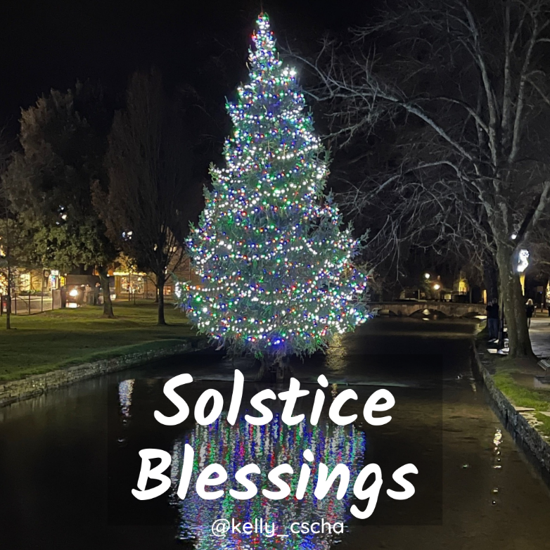

One of the most spiritually significant days of the year the winter solstice marks the turning of nature’s wheel of life, and the movement of our Sun into the zodiac sign of Capricorn and astronomically it is the first day of Winter. On this special day it is the longest night, and thus the shortest day and precisely marks the point that soon the daylight will last longer (in the northern hemisphere) and that life will re-emerge after its winter slumber when the spring arrives. Modern society tends to recognise this as an ending especially of our calendar year is almost completed and yet in agriculture our ancestors acknowledged It as the beginning.

The term Solstice is derived from the latin “Sol” (Sun) and “Sistere” (be still). Energetically as we too are nature it reminds us that we must preserve our energy as our day light time and energy is limited. Whilst in this darkest part of the year you may feel inclined to reflect about the past and self-nurturing is advised to support the transformation of any fears as you seek the truth.

This year is on the Tuesday 21st of December at 15:59 (GMT) in the Northern Hemisphere

Winter Solstice celebrations and Yule usually centre around the birth of a Divine Son/Sun as a saviour. Different cultures tell stories with much loved characters to tell this annual story. We have Mother Mary, Jesus and Joseph, or Isis, Horus and Osiris (note that neither Joseph or Osiris actually physically inseminated the Mother – is this the Divine Sun insemination – seed?)

Metaphorically speaking at winter solstice, the sun is at its weakest and can be seen as a baby that will grow and get stronger.

According to Celtic myths, the Solstice marked the annual battle between the Oak King (representing light) and the Holly King (representing dark). On the Winter Solstice it was always the Oak King that won!

The outside physical sun also represents our inner sun or rather the spark of consciousness that resides in our heart. After the Winter Solstice it is nurtured by the growing physical sun and our confidence grows. For the next couple of months our inner darkness is gradually transformed into illumination and enlightenment.

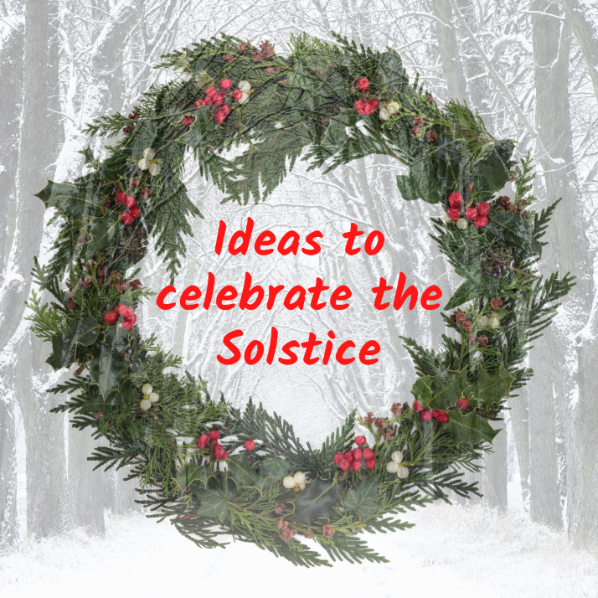

🔥Decorate a Yule Tree (aka Christmas Tree)
🔥 Carefully and mindfully select your Yule logs and build a bonfire.
🔥 Visit a sacred site like Avebury, Stanton Drew, the Rollrights, the Hurlers etc.
🔥 Create a Yule Altar – suggestions are Holly branches, Mistletoe, red, gold and green candles, photos of sacred sites and crystals like Black Onyx for reflective practise, Snowy Quartz for its calming influence, Snowflake Obsidian for supporting the rising of hidden unconscious blocks into the conscious mind, Smoky Quartz for dissolving fears and Ruby for protection, vitality and manifesting intentions.
🔥 Set intentions for the coming year.
🔥 Practise gratitude.

Solstice Blessings to you and All.
Blessed Be.
Kelly x

